# **CHAPTER FIVE**

## **5.0 SYSTEM DESIGN**

### **5.1 Introduction**

System design is a crucial phase in the development of any software application, including an online customizable food ordering system. The system design process involves careful planning, analysis, and consideration of all aspects of the system's operation, from user interface to database design. The goal is to create a system that is intuitive and user-friendly while also ensuring data integrity, accuracy, and security. In this chapter, we will outline the architecture, process design, database design, and interface design of our online customizable food ordering system, taking into account the specific needs and requirements of our users and stakeholders. By the end of this chapter, we aim to have a clear and comprehensive understanding of how the system will function and how it will meet the needs of all stakeholders.

### **5.2 Architecture**

#### **5.2.1 System Architecture**

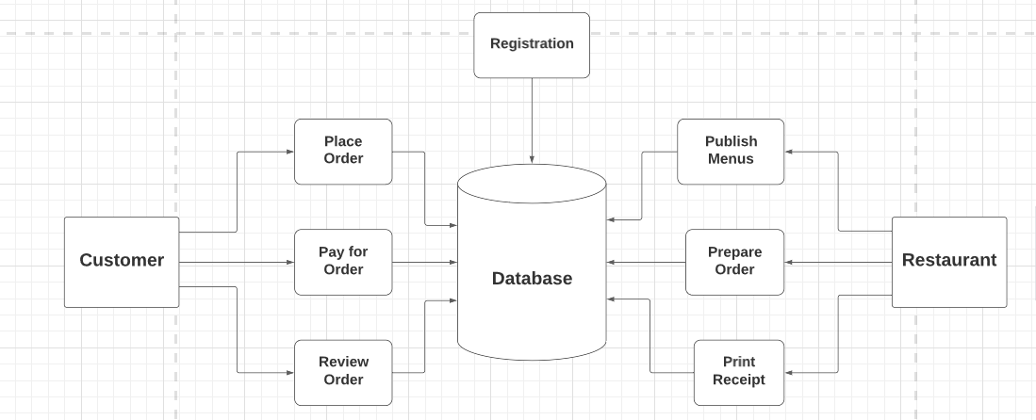

#### **5.2.2 Hardware architecture**

The web server is the main component that serves web pages and provides API responses to client requests. It may also handle user authentication and authorization. The application server manages user accounts, stores data, executes the system's business logic, and processes requests from the client. It communicates with the database server to store and retrieve data. The database server houses the data, including user accounts, application data, and other relevant data. The client is the user interface that interacts with the system, sending requests to the web server and receiving responses. APIs are used to facilitate communication between the different components of the system, allowing the client to interact with the application server and the database server to access and manipulate data. Overall, the hardware structure of the website is designed to support the efficient and secure processing of user requests and the storage and retrieval of data from the database.

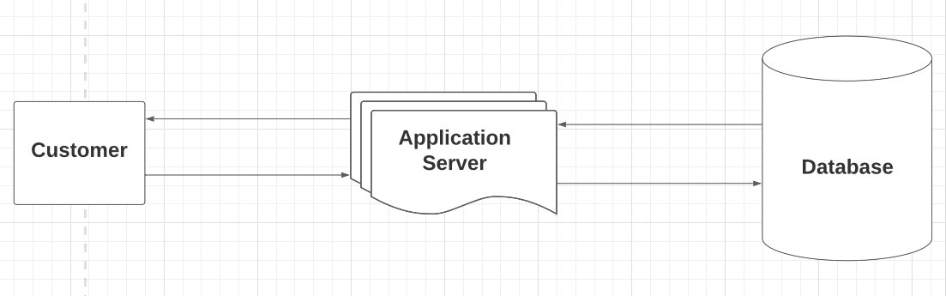

### **5.3 Process design**

This phase will involve definition of software and hardware specifications and showing how the frontend of the proposed system will interact with the backend.

#### **5.3.1 Hardware specifications**

|  |  |
| --- | --- |
| **Requirements** | **Hardware** |
| **Primary memory** | 6 GB of RAM or higher |
| **Processor** | Intel Core i5 2.0 GHz and Higher |
| **Architecture** | x64 (64 Bit) |

#### **5.3.2 Software specifications**

|  |  |
| --- | --- |
| **Requirements** | **Software** |
| **Operating System** | Microsoft Windows 10 |
| **Database Management System** | MYSQL |
| **Programming Languages** | HTML, CSS, JavaScript, Python |
| **Framework** | Django |
| **Web Server** | Django built-in Server |

#### **5.3.3 Component Diagram for proposed system**

The component diagram for the proposed Online Teacher Recruitment System shows how small components within the frontend and backend will interact and interconnect to form a complex system that meets user needs.

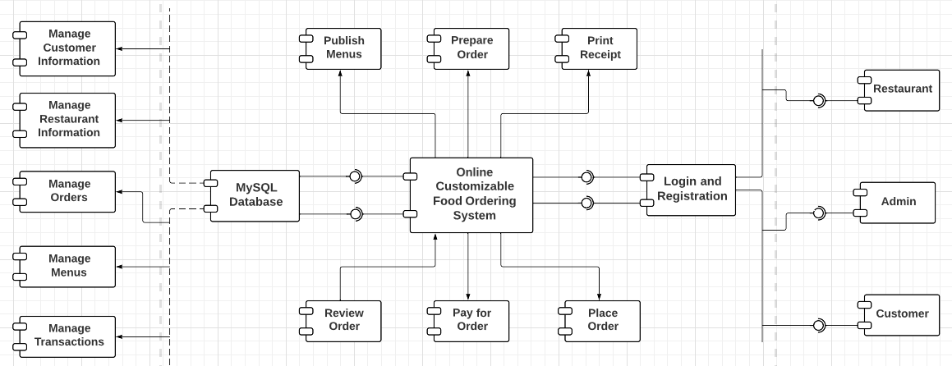

### **5.4 Database design**

#### **5.4.1 The proposed system uses the following tables**

* User
* Customer
* Restaurant
* Menu
* Category
* MenuItem
* Review
* Order
* Transaction

**User Table**

|  |  |  |  |
| --- | --- | --- | --- |
| **Field** | **Data Type** | **Null** | **Key** |
| UserID | INT | NO | PK |
| Password | VARCHAR (128) | NO |  |
| Last_login | DATETIME | NO |  |
| Is_superuser | TINYINT (1) | NO |  |
| Username | VARCHAR (150) | NO |  |
| First name | VARCHAR (150) | YES |  |
| Last name | VARCHAR (150) | YES |  |
| Email | VARCHAR (254) | NO |  |
| Is_staff | TINYINT (1) | NO |  |
| Date_joined | DATETIME | NO |  |
| Is_customer | TINYINT (1) | NO |  |
| Is_restaurant | TINYINT (1) | NO |  |

**Customer Information Table**

|  |  |  |  |
| --- | --- | --- | --- |
| **Field** | **Data Type** | **Null** | **Key** |
| UserID | INT | NO | FK |
| Username | VARCHAR (100) | NO |  |
| Contact | VARCHAR (100) | NO |  |

**Restaurant Table**

|  |  |  |  |
| --- | --- | --- | --- |
| **Field** | **Data Type** | **Null** | **Key** |
| UserID | INT | NO | FK |
| Username | VARCHAR (100) | NO |  |
| Name | VARCHAR (100) | NO |  |
| Contact | VARCHAR (100) | NO |  |
| Image | VARCHAR (100) | NO |  |
| Location | VARCHAR (100) | NO |  |
| Open time | TIME | NO |  |
| Close time | TIME | NO |  |

**Menu Table**

|  |  |  |  |
| --- | --- | --- | --- |
| **Field** | **Data Type** | **Null** | **Key** |
| MenuID | INT | NO | PK |
| RestaurantID | INT | NO |  |

**Category Table**

|  |  |  |  |
| --- | --- | --- | --- |
| **Field** | **Data Type** | **Null** | **Key** |
| CategoryID | INT | NO | PK |
| Name | VARCHAR (50) | NO |  |

**MenuItem Table**

|  |  |  |  |
| --- | --- | --- | --- |
| **Field** | **Data Type** | **Null** | **Key** |
| MenuItemID | INT | NO | PK |
| Name | VARCHAR (255) | NO |  |
| Description | LONGTEXT | NO |  |
| Image | VARCHAR (100) | NO |  |
| Price | INT | NO |  |
| Calories | INT | NO |  |
| Proteins | INT | NO |  |
| Carbs | INT | NO |  |
| Fat | INT | NO |  |
| CategoryID | INT | NO |  |
| MenuID | INT | NO |  |

**Review Table**

|  |  |  |  |
| --- | --- | --- | --- |
| **Field** | **Data Type** | **Null** | **Key** |
| ReviewID | INT | NO | PK |
| Review text | LONGTEXT | NO |  |
| Rating | INT | NO |  |
| MenuItemID | INT | NO |  |
| CustomerID | INT | NO |  |
| Timestamp | DATETIME | NO |  |

**Order Table**

|  |  |  |  |
| --- | --- | --- | --- |
| **Field** | **Data Type** | **Null** | **Key** |
| OrderID | INT | NO | PK |
| Created on | DATETIME | NO |  |
| Special instructions | LONGTEXT | NO |  |
| Order type | VARCHAR (20) | NO |  |
| Order status | VARCHAR (20) | NO |  |
| Price | INT | NO |  |
| Fat | INT | NO |  |
| Carbs | INT | NO |  |
| Protein | INT | NO |  |
| Calories | INT | NO |  |
| Is_customer | INT | NO |  |
| Is_restaurant | INT | NO |  |

**Transaction Information Table**

|  |  |  |  |
| --- | --- | --- | --- |
| **Field** | **Data Type** | **Null** | **Key** |
| TransactionID | INT | NO | PK |
| OrderID | INT | NO |  |
| CustomerID | INT | NO |  |
| RestaurantID | INT | NO |  |
| Timestamp | DATETIME | NO |  |
| Amount | INT | NO |  |

**Order-MenuItem Table**

|  |  |  |  |
| --- | --- | --- | --- |
| **Field** | **Data Type** | **Null** | **Key** |
| Order-MenuItemID | INT | NO |  |
| OrderID | INT | NO |  |
| MenuItemID | INT | NO |  |

#### **5.4.2 ERD**

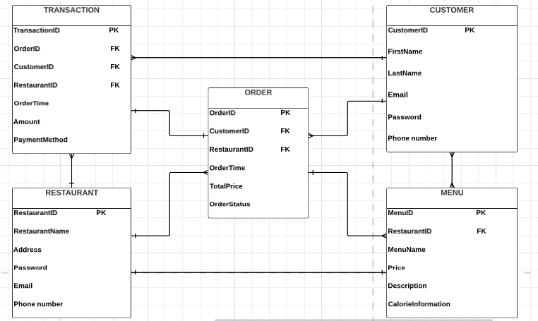

**Normalization**

The normalization of the tables can be represented as follows:

First Normal Form (1NF):

* All tables have a primary key field which is unique and not null.
* The values in each column of a table are atomic, meaning that they cannot be broken down into smaller pieces.
* There are no repeating groups of columns.

Customer Information Table:

* CustomerID is the primary key field.
* Each column contains atomic values.
* There are no repeating groups of columns.

Restaurant Information Table:

* RestaurantID is the primary key field.
* Each column contains atomic values.
* There are no repeating groups of columns.

Order Information Table:

* OrderID is the primary key field.
* CustomerID and RestaurantID are foreign key fields that reference the primary keys of the Customer and Restaurant tables, respectively.
* Each column contains atomic values.
* There are no repeating groups of columns.

Transaction Information Table:

* TransactionID is the primary key field.
* OrderID, CustomerID, and RestaurantID are foreign key fields that reference the primary keys of the Order, Customer, and Restaurant tables, respectively.
* Each column contains atomic values.
* There are no repeating groups of columns.

Menu Information Table:

* MenuID is the primary key field.
* RestaurantID is a foreign key field that references the primary key of the Restaurant table.
* Each column contains atomic values.
* There are no repeating groups of columns.

Second Normal Form (2NF):

* The table is in 1NF.
* All non-key columns are fully dependent on the primary key.

Customer Information Table:

* The table is already in 2NF.

Restaurant Information Table:

* The table is already in 2NF.

Order Information Table:

* The table is already in 2NF.

Transaction Information Table:

* The table is already in 2NF.

Menu Information Table:

* The table is already in 2NF.

Third Normal Form (3NF):

* The table is in 2NF.
* There are no transitive dependencies between non-key columns.

Customer Information Table:

* The table is already in 3NF.

Restaurant Information Table:

* The table is already in 3NF.

Order Information Table:

* The table is already in 3NF.

Transaction Information Table:

* The table is already in 3NF.

Menu Information Table:

* The table is already in 3NF.

### **5.5 User Interface Design**

#### **5.5.1 Homepage**

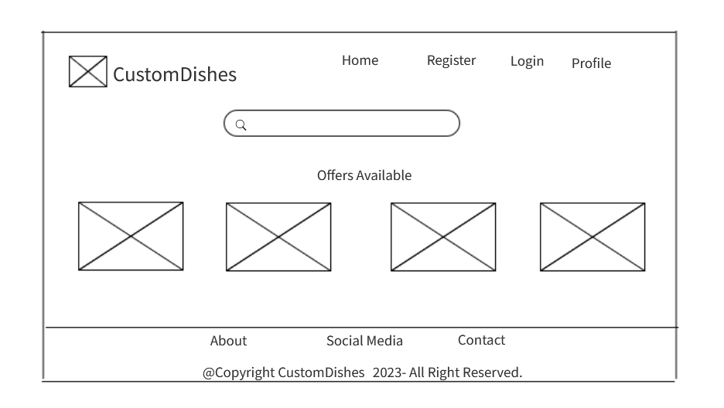

#### **5.5.2 Login**

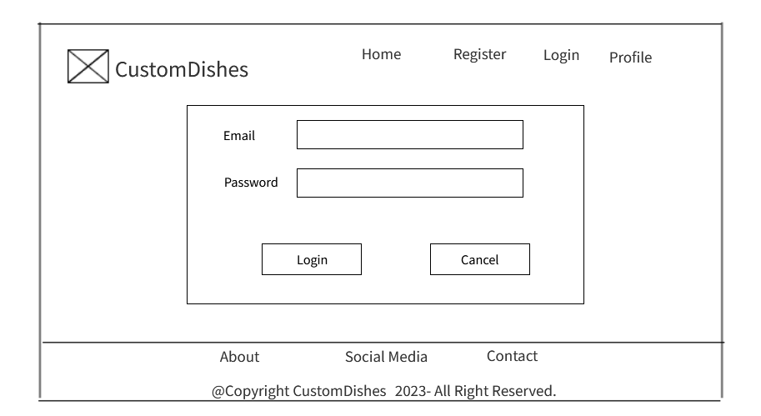

#### **5.5.3 Sign up**

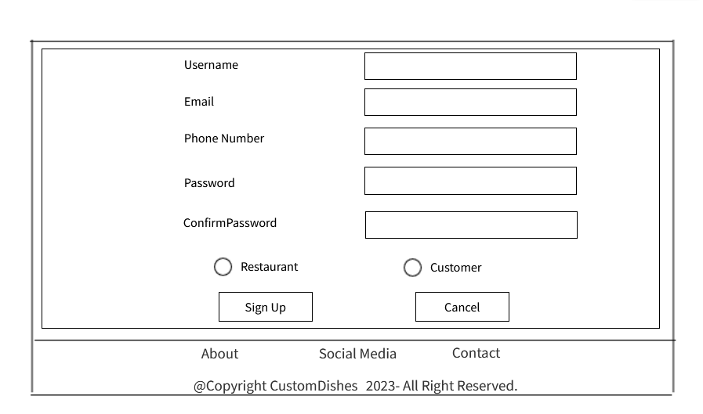

#### **5.5.4 Customer homepage**

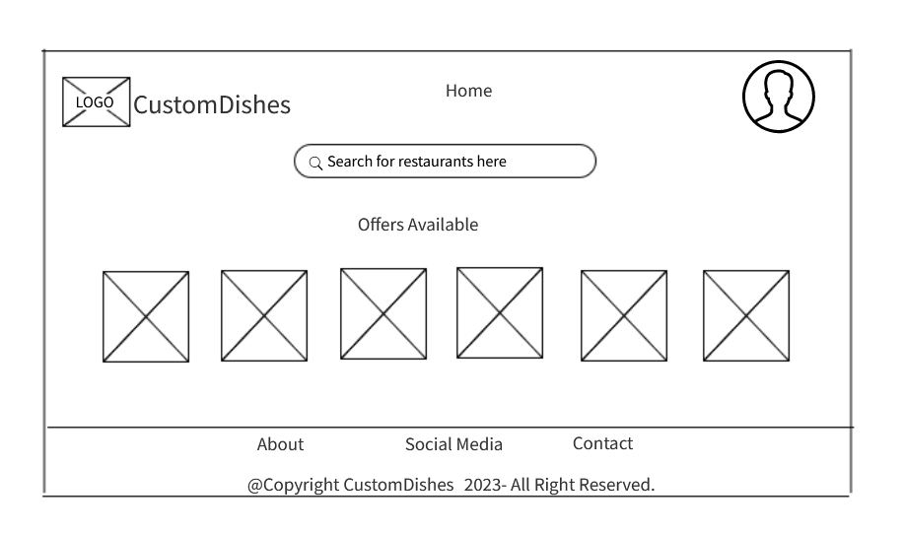

**5.5.5 Restaurant homepage**

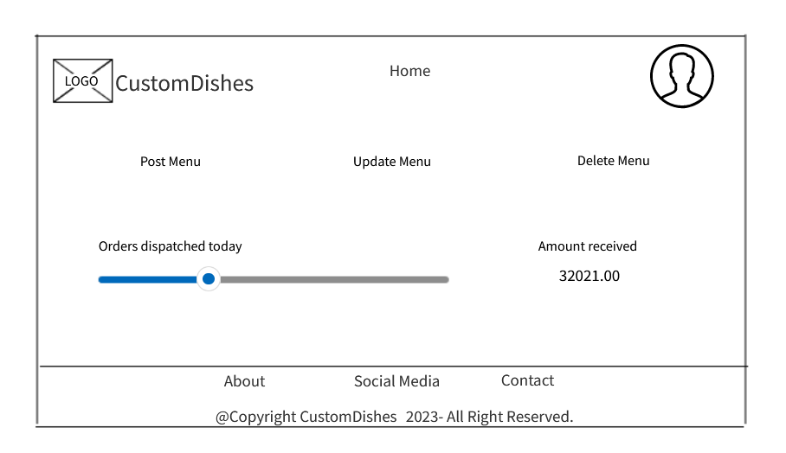

#### **5.5.6 Admin Dashboard**

